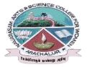
NAVARASAM ARTS AND SCIENCE COLLEGE FOR WOMEN
ARACHALUR, ERODE-638101
STAFF PROFILE
Name | 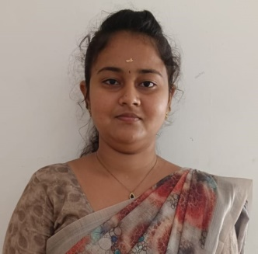  Ms.A.Vinitha
Designation | Assistant Professor in Commerce
Qualification | M.Com, (Ph.D).,
Department | Commerce
Phone No. | Office
 | Mobile |  | 6385848189
Email | - vinithavini2009@gmail.com
Areas of Interest/  Specialization | Finance and Marketing
Subjects Taught | UG: PG: Nil  - Financial Accounting – I  - Business Law  - Executive business communication  - Business organization and office management  - Principles of Accountancy  - Principles of Management  - Principles of Marketing  - Auditing and Assurance-II
Date of Joining in our Institution | 07.06.2023
Experience (in Years) | Industry |  |  | Nil
 | Teaching |  |  | 1 Year and 6 Months
 | Research |  |  | Nil
 | Total |  |  | 1 Year and 6 Months
Research Publications in Journals | Nil
Papers Published in Conference Proceedings | Nil
Books / Chapters  Published | Nil
Patent Published | Nil
Research Projects  Major/ Minor |  | Completed |  |  |  | Nil
 |  | Undergoing |  |  |  | Nil
Research Guidance |  | Awarded |  |  |  | Undergoing
 |  | Nil |  |  |  | Nil
Conferences |  | Attended |  |  | Presented |  |  | Organized
National |  | - Innovation & Entrepreneurship in Logistics Management  - Innovation in Business and Economy – Opportunities and challenges  - National commission for women “ Effective breast cancer awareness programme”. |  |  | Nil |  |  | Nil
International |  | Nil |  |  | Nil |  |  | Nil
Workshops |  | Attended |  |  |  |  | Organized
 |  | Online workshop on “ General paper on Teaching and research aptitude(UGC NET: Paper 1) |  |  |  |  | Nil
FDP |  | Attended |  |  |  |  | Organized
 |  | Nil |  |  |  |  | Nil
Seminar / Webinar |  | Attended |  |  |  |  | Organized
 |  | - National stock exchange sponsored webinar on “ Investment awareness program”  - State level webinar on “Tamizhum tamizharum “organized by Maxrein research institute & Consultancy. |  |  |  |  | Nil
Membership |  | Nil
Acted as Resource Person |  | Nil
Awards |  | Awarded University Rank I in PG.
Online Courses |  | Completed |  |  |  |  | Enrolled
 |  | Global Marketing (NPTEL SWAYAM) |  |  |  |  | Nil
Extension Activities (NSS/YRC) / Club In charge |  | Nil
Administrative Assignments Handled |  | Nil
Association with Professional Bodies |  | Nil
Any other Achievements |  | Nil
Orchid / Google Scholar/  Research ID |  | Nil

