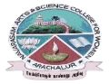
NAVARASAM ARTS AND SCIENCE COLLEGE FOR WOMEN
ARACHALUR, ERODE-638101
STAFF PROFILE
Name | Mrs.S.GOMATHI  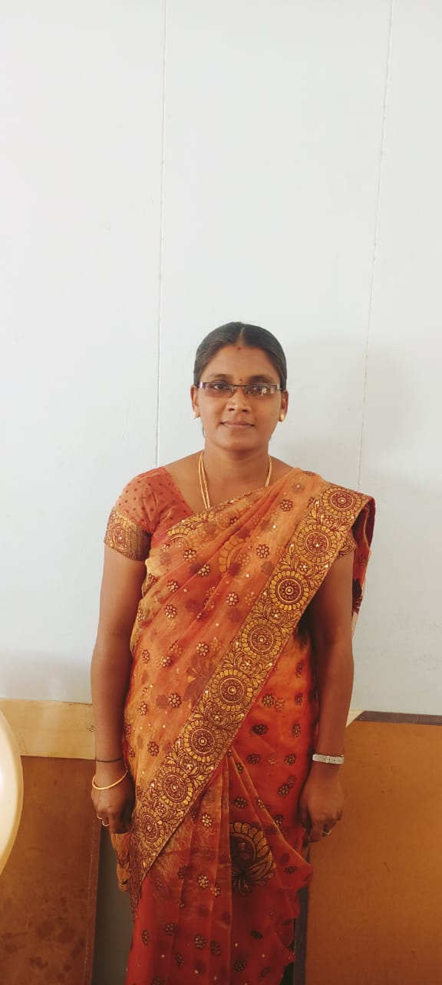
Designation | Assistant Professor
Qualification | M.A., M.Phil., B.Ed., C.L.I.Sc.,
Department | English
PhoneNo. | Office | -
 | Mobile | 9566613455
Email | 1.gomathisuresk@gmail.com  2.gomathisivagiri88@gmail.com
AreasofInterest/  Specialization | Indian Writing in English
SubjectsTaught | UG: English Language Teaching, Indian Writing in English, Literary Forms,Drama, Linguistics, PG: The English Language ,English Literature for Competitive Examination,Medical Tanscription,British Literature.
Date of Joining in our Institution | 10.12.2012
Experience(inyears) | Industry |  | -
 | Teaching |  | 13 years 6 months
 | Research |  | 2 years
 | Total |  | 13 years 6 months
Research Publications in Journals | 06
Papers Published in Conference Proceedings | NIL
Books / Chapters  Published | 06
Patent Published | NIL
Research Projects  Major/ Minor | Completed |  |  | NIL
 | Undergoing |  |  | NIL
Research Guidance | Awarded |  |  | Undergoing
 | 02 |  |  | NIL
Conferences | Attended | Presented |  | Organized
National | 81  F | NIL |  | NIL
International | 05 | 04 |  | 01
Workshops | Attended |  | Organized
 | 03 |  | 03
FDP | Attended |  | Organized
 | 20 |  | NIL
Seminar/Webinar | Attended |  | Organized
 | 28 |  | 01
Membership | NIL
Acted as Resource Person | NIL
Awards | NIL
Online Courses | Completed |  | Enrolled
 | 06 |  | NIL
Extension Activities (NSS/YRC) / Club In charge | Theatre Club Co-Ordinator.  Co-Ordinator - Seminor/ Conference /Guest Lecturer/Workshop.
Administrative Assignments Handled | Member in Assembly Committee  Member in Grievance & Redressal Cell  Member in IT Wing
Association with Professional Bodies | Acted AS QUESTION PAPER SETTER IN AUTONOMOUS COLLEGES.  Acted As External Examiner in Viva-voce
Any other Achievements | Publication of Tamil Poem
Orchid / Google Scholar/  Research ID | gomathisuresk28@navarasam.edu.in

