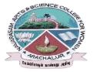
NAVARASAM ARTS AND SCIENCE COLLEGE FOR WOMEN
ARACHALUR, ERODE-638101
STAFF PROFILE
Name |  | Mrs.K.PREETHA  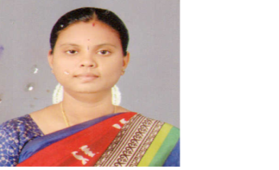
Designation |  | ASSISTANT PROFESSOR
Qualification |  | D.C.E., M.A., B.Ed., M.Phil.,
Department |  | ENGLISH
PhoneNo. |  | Office |  | -
 |  | Mobile |  | 9976552655
Email |  | preethahari24@gmail.com
AreasofInterest/  Specialization |  | BRITISH LITERATURE
SubjectsTaught |  | UG: UG: Prose, Fiction, Drama, Poetry, History of English Literature, Social History of England, American Literature, Indian Writing in English, Literary Forms  PG: Literary Criticism and Theory, Methods of teaching English, Indian writing in English, New literature in English
Date of Joining in our Institution |  | 04.06.2014
Experience(inyears) |  | Industry |  |  | -
 |  | Teaching |  |  | 10 years 5 months
 |  | Research |  |  | -
 |  | Total |  |  | 10 years 5 months
Research Publications in Journals |  | 04
Papers Published in Conference Proceedings |  | NIL
Books / Chapters  Published |  | 04
Research Projects  Major/ Minor |  | Completed |  |  |  |  | NIL
 |  | Undergoing |  |  |  |  | NIL
Research Guidance |  | Awarded |  |  |  |  | Undergoing
 |  | NIL |  |  |  |  | NIL
 | Conferences |  | Attended |  |  | Presented |  |  | Organized
 | National |  | NIL |  |  | NIL |  |  | NIL
 | International |  | 05 |  |  | 04 |  |  | NIL
 | Workshops |  | Attended |  |  |  |  | Organized
 |  |  | 06 |  |  |  |  | NIL
 | FDP |  | Attended |  |  |  |  | Organized
 |  |  | 21 |  |  |  |  | NIL
 | Seminar/Webinar |  | Attended |  |  |  |  | Organized
 |  |  | 28 |  |  |  |  | NIL
 | Membership |  | NIL
 | Acted as Resource Person |  | NIL
 | Membership |  | NIL
 | Awards |  | 2
 | Online Courses |  | Completed |  |  |  |  | Enrolled
 |  |  | NIL |  |  |  |  | NIL
 | Extension Activities (NSS/YRC) / Club In charge |  | 1.Literary Association Co-Ordinator  2.Naan Mudhalvan
 | Administrative Assignments Handled |  | 1.IQAC Co-Ordinator  2.Seating Committee  3.MOC Committee  4.Minutes in-charge
 | Association with Professional Bodies |  | NIL
 | Any other Achievements |  | NIL
 | Orchid / Google Scholar/  Research ID |  | preethahari24@navarasam.edu.in

