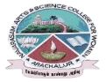
NAVARASAM ARTS AND SCIENCE COLLEGE FOR WOMEN
ARACHALUR, ERODE-638101
STAFF PROFILE
Name | Mrs.P.VIJAYA  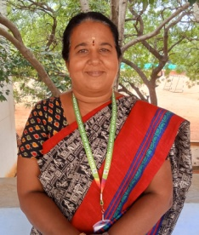
Designation | ASSISTANT PROFESSOR
Qualification | MA.,M.Phil.,
Department | TAMIL DEPARTMENT
Phone No. | Office
 | Mobile | 9443467809
Email | 1. vijayakarthikeysn15@gmail.com  2.
Areas of Interest/  Specialization | MODERN LITERATURE
Subjects Taught | UG: KAPPIYANGAL PG: SANGA ILAKKIYAM  KANIPPORI THOLLKAPPIYAM  TAMIL ILAKKIYA VARALARU TAMIL ILAKKANA VARALARU  TAMIL MOZHI VARALARU OPPILAKKIYAM  TAMILAZHA VARALARUM INDIA MOZHIKALIN VARALARU  PANPADUM
Date of Joining in our Institution | 06.06.2007
Experience (in Years) | Industry |  | Nil
 | Teaching |  | 17 Yrs
 | Research |  | 14 Yrs
 | Total
Research Publications in Journals | Nil
Papers Published in Conference Proceedings | Nil
Books / Chapters  Published | Nil
Patent Published | Nil

Research Projects  Major/ Minor | Completed |  | NIL
 | Undergoing
Research Guidance | Awarded |  | Undergoing
 | ---- |  | ----
Conferences | Attended | Presented |  |  | Organized
National | 01 | 01 |  |  | Nil
International
Workshops | Attended |  |  | Organized
 | Nil |  |  | Nil
FDP | Attended |  |  | Organized
 | 02 |  |  | Nil
Seminar / Webinar | Attended |  |  | Organized
Seminar:
International Webinar: 01
Membership | Nil
Acted as Resource Person | Nil
Awards | Nil
Online Courses | Completed |  |  | Enrolled
 | NIL |  |  | NIL
Extension Activities (NSS/YRC) / Club In charge | NIL
Administrative Assignments Handled | NIL
Association with Professional Bodies | Nil
Anyother Achievements | Nil
Orchid / Google Scholar/  Research ID | Nil

